Eleanor Mary Klott Heberle 1926-2015 Hermann MO
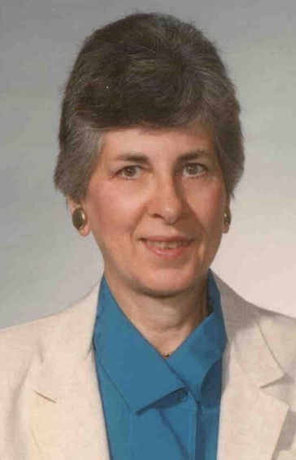
Eleanor Mary Heberle, 88, of Hermann, Missouri, passed away on Wednesday, Jan. 28, 2015, at Frene Valley Health Center.
Mrs. Heberle was born in Hermann, Missouri, on June 9, 1926, the daughter of the late William and Collette (Schneider) Klott.
She was the widow of Raymond E. “Kayo” Heberle. They were married Sept. 27, 1947, at St. Joseph Catholic Church, Little Berger, Missouri. Raymond preceded her in death on Nov. 21, 2007.
Eleanor was a member of St. George Church, where she was a member of the Ladies Sodality. She worked at Hermann High School as a cook for many years. She also worked at Handi-Pac.
Eleanor is survived by her three children, daughter Joan Livingston and husband Randy of Shelbyville, Indiana, son Terry Heberle and wife Karen of Rocky Mount, North Carolina, and son William Heberle and wife Marcia of Jefferson City;
By a brother, Tony Klott and wife Bonnie of Bowling Green, Missouri; two sisters, Joan Eckerle of New Haven, Missouri, and Bernadette Overkamp and husband Norbert of Waukesha, Wisconsin; a sister-in-law, Betty Klott of Hermann, Missouri;
By her grandchildren, Lori Miller, Michael Livingston, Nicholas Heberle and Anna Heberle; and by great-grandchildren Mason, Luke amd Alex Miller and Jacob Livingston.
She is preceded in death by her parents, her husband, a daughter, Patricia Ann Heberle, and by three brothers, Maurice, Leo and James Klott.
Visitation was held Friday, Jan. 30, 2015. from 9:30-11:30 a.m. at St. George Church, Hermann, Missouri, where a funeral mass followed at 11:30 a.m., with Father Bill Debo officiating.
Burial was in St. George Cemetery.

